**HIVE EXAM PREPERATION**

1. Detect Spikes in Fraudulent activities over time?

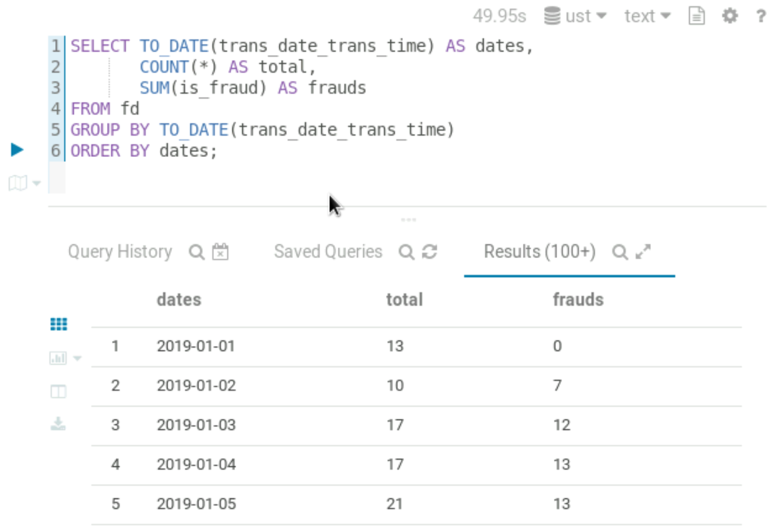

1. Find users with unusually high spending in a single day?

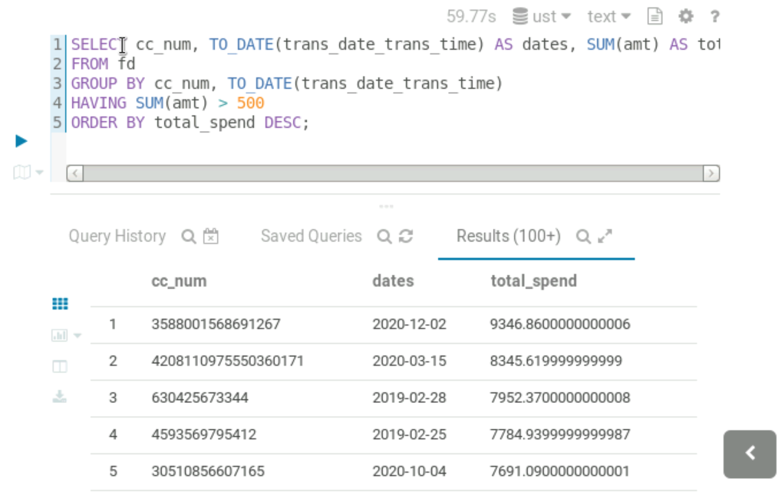

1. Users with more diverse spending categories?

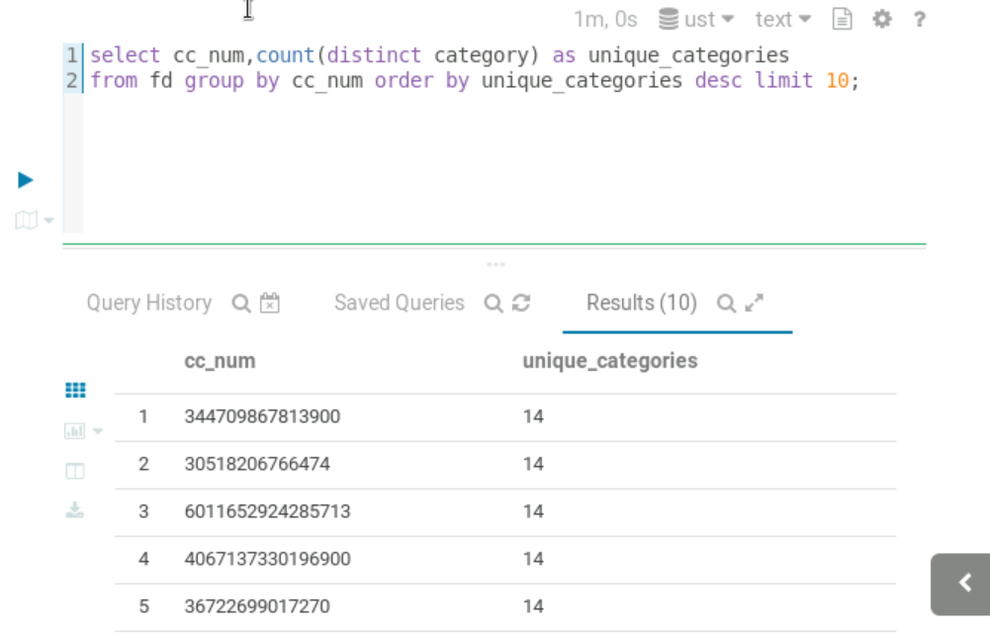

1. Which merchant has the most transactions?

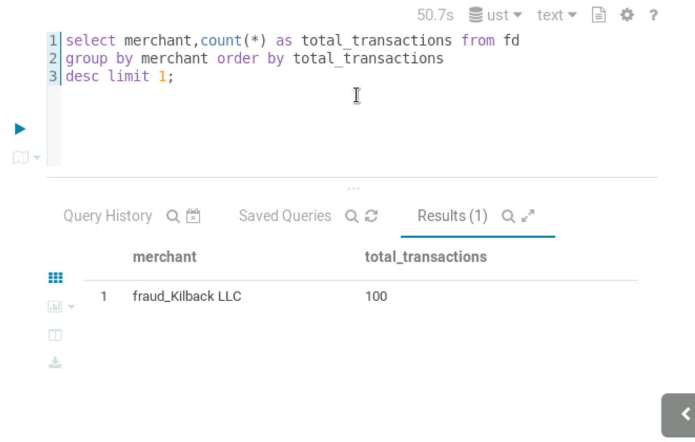

1. Top 5 Risky merchants by Fraud?

